7. Create a Virtual Machine with 1 vCPU, 2GB RAM an 15GB storage disk using a Type 2 Virtualization Software:

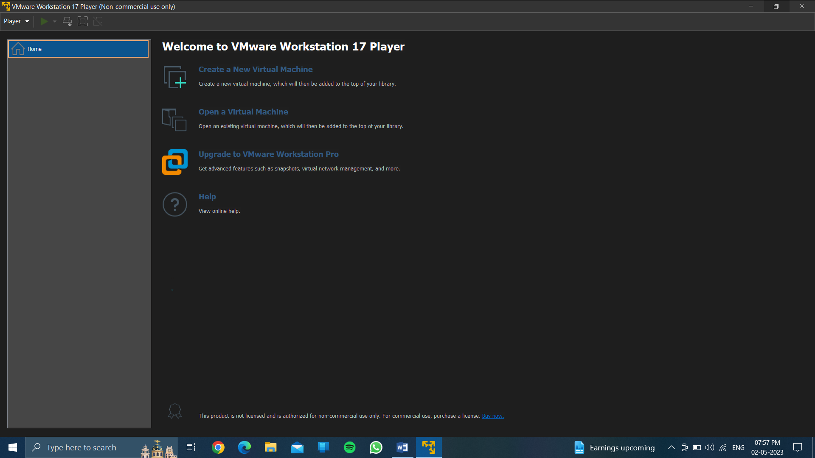

1. Create a new vitual machine.

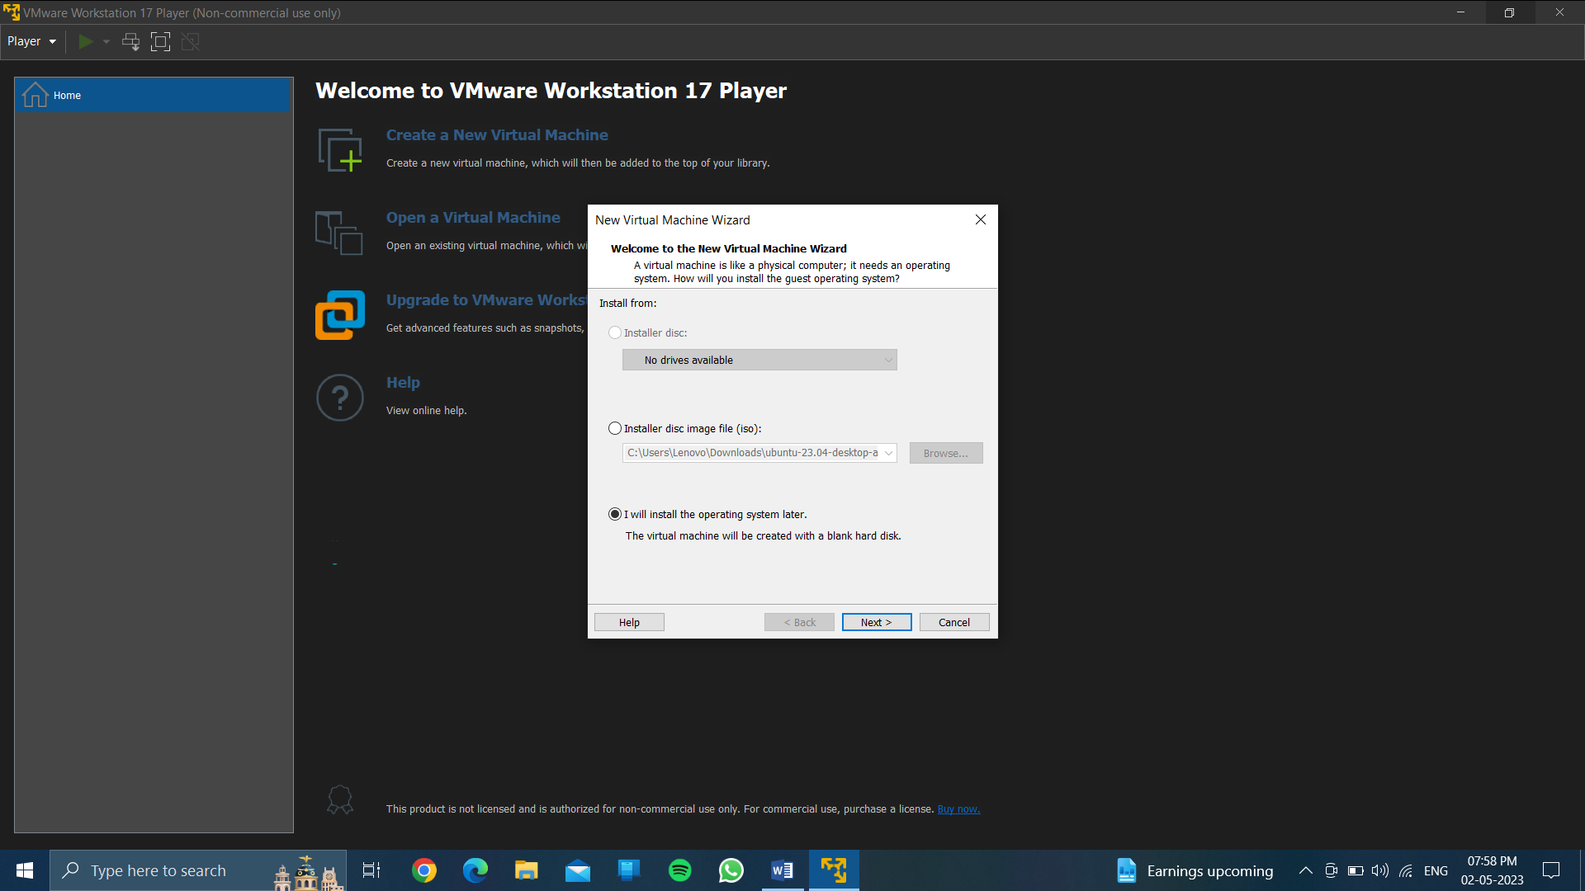

Click on I will install the os later. Click on next….



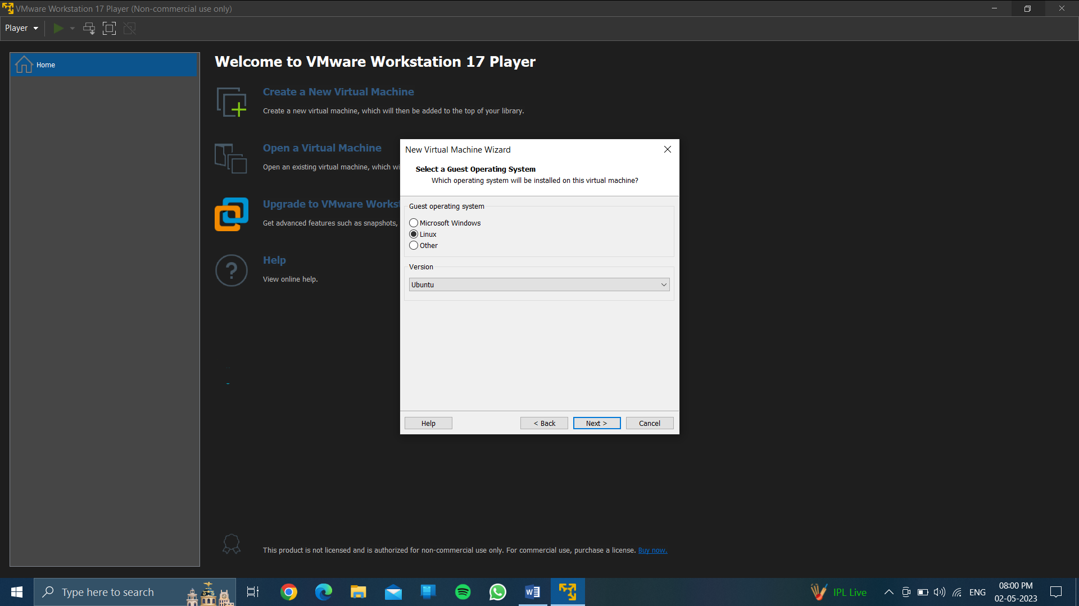

Choose linux and version Ubuntu….

Click on next…..

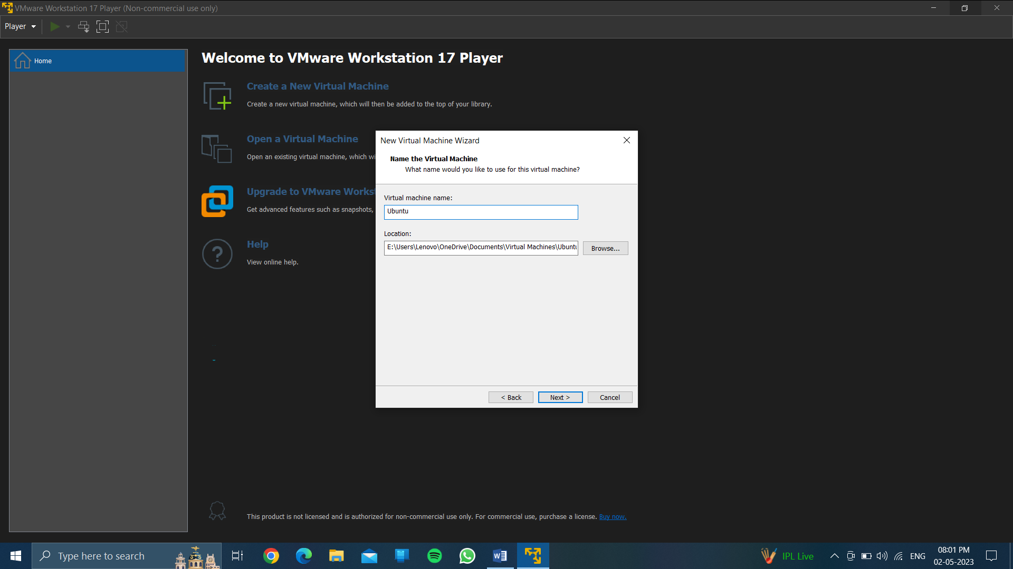

Click on next….

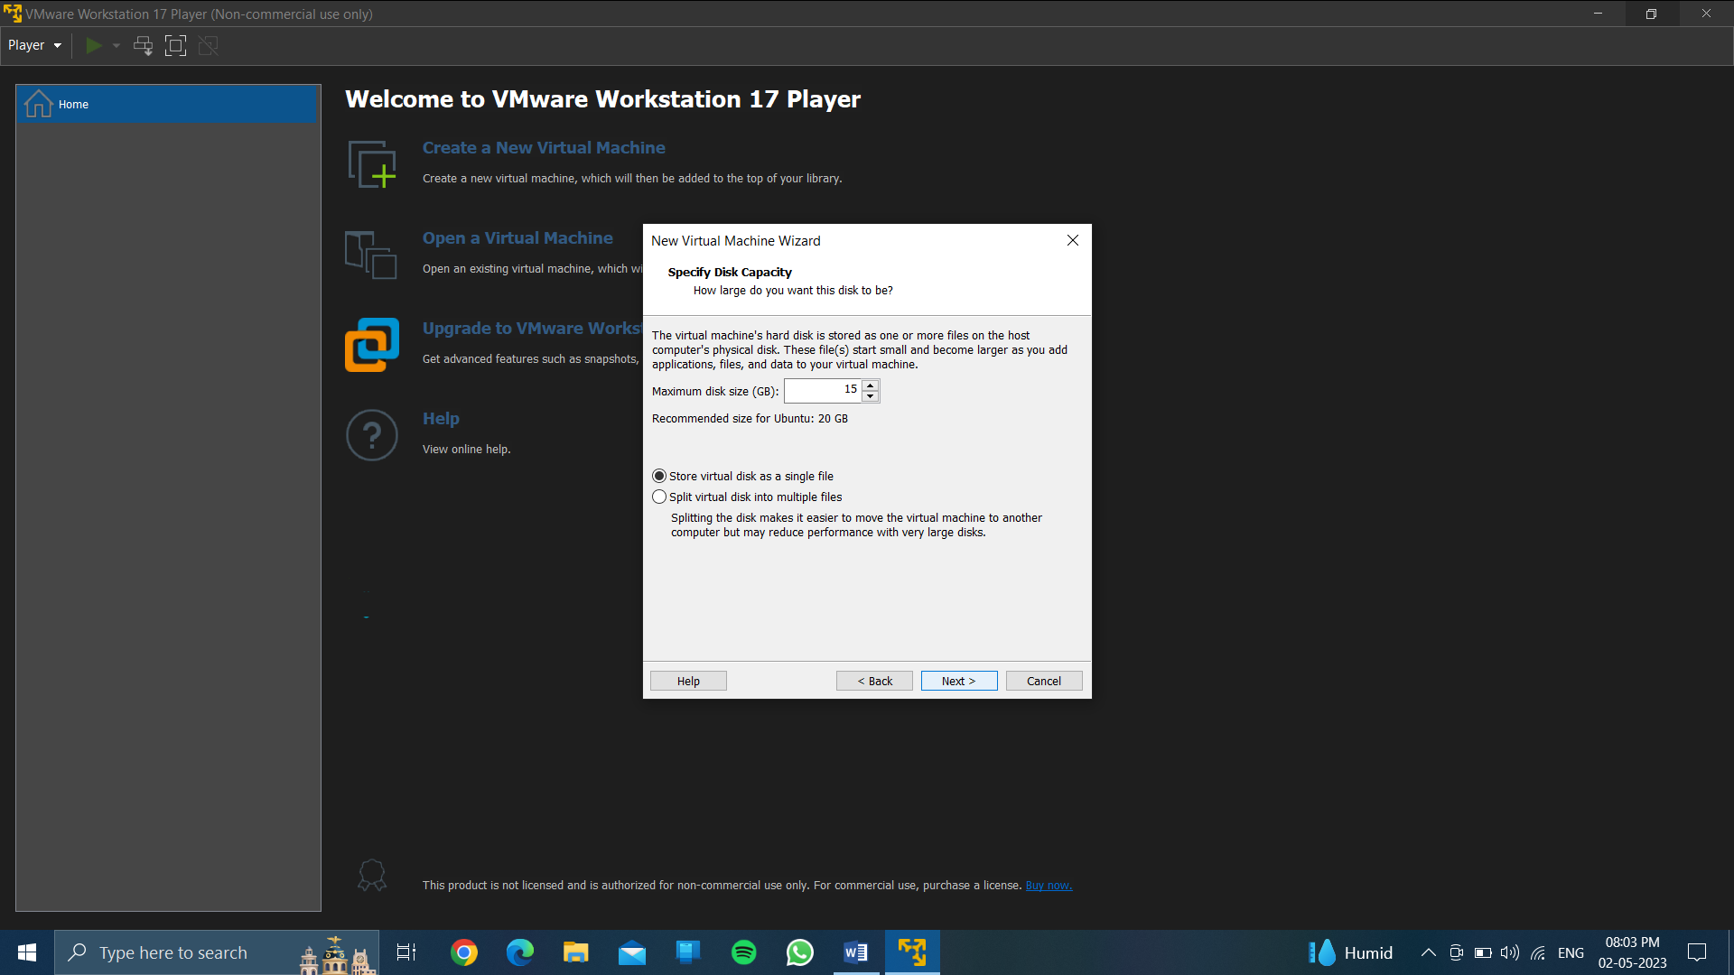

Choose 15 gb max size & store in a single file..

Click on next…

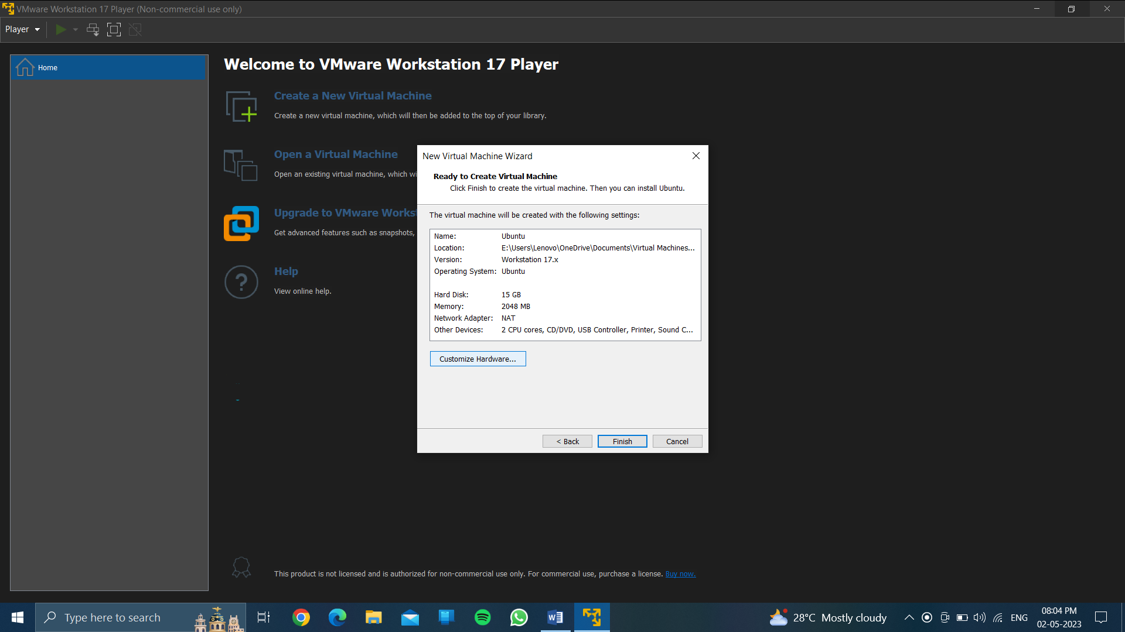

Click on customize hardware…

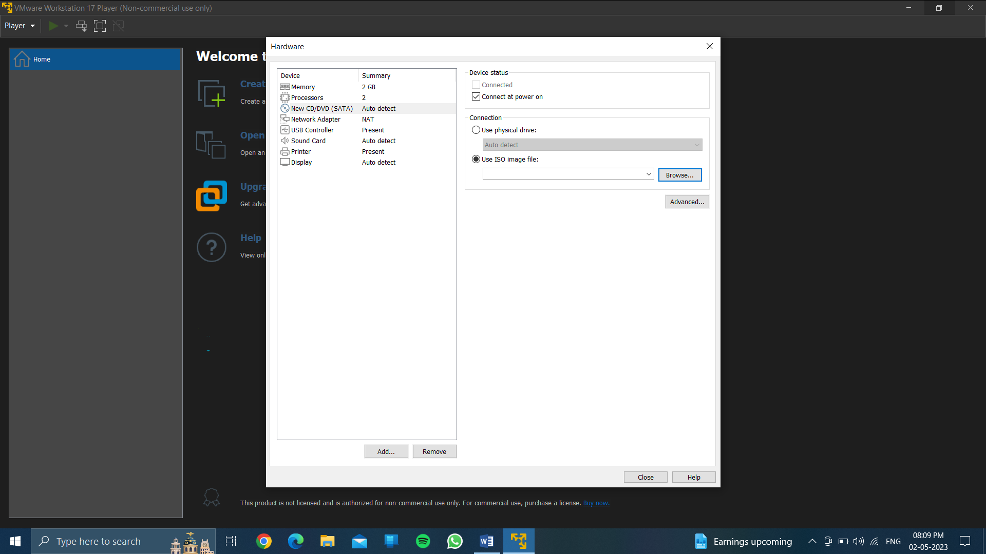

Click on new cvd /cd (sata)….

Choose iso image file….

Click on browse…..

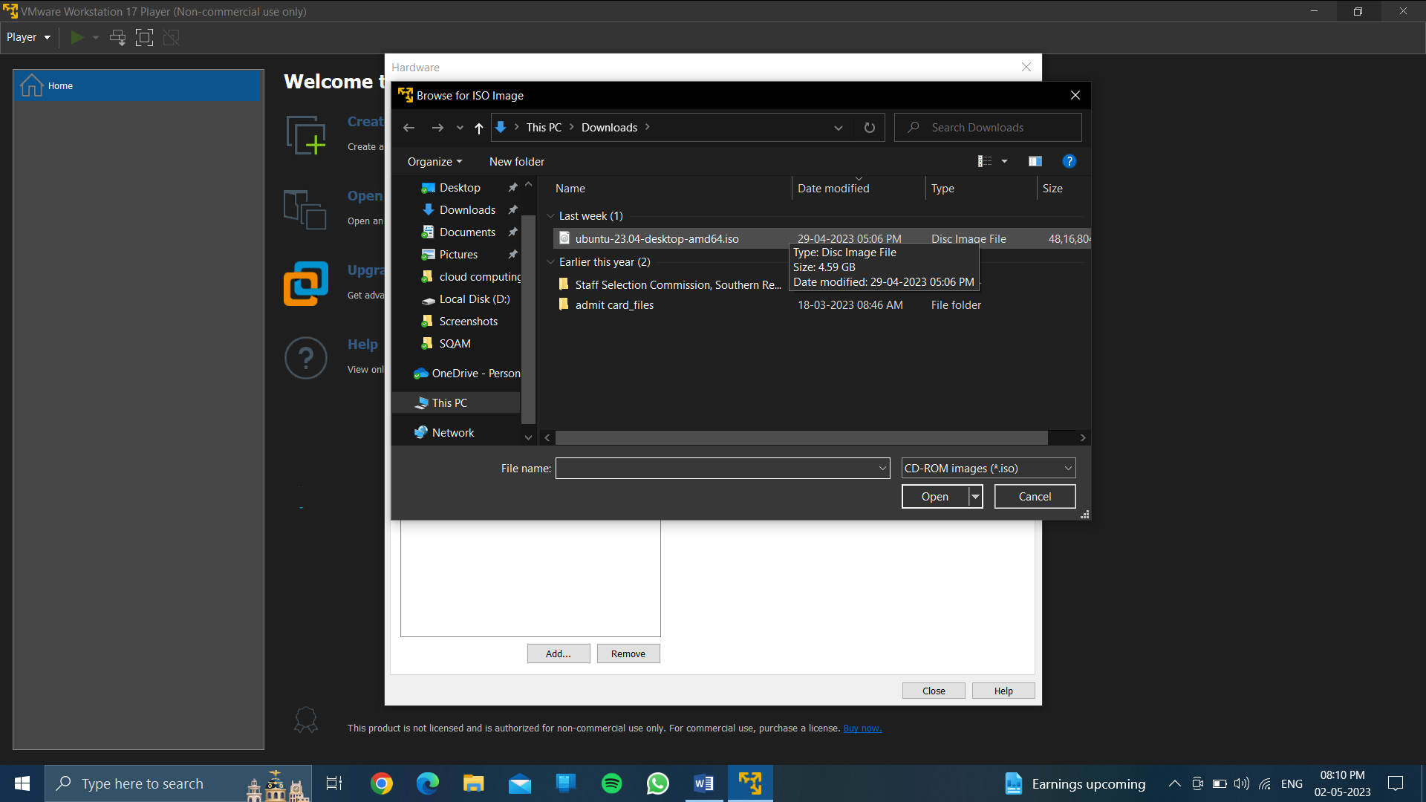

Download the ubuntu desktop image file in format is0…

Choose Ubuntu-23.o4 desktop-amd64.iso

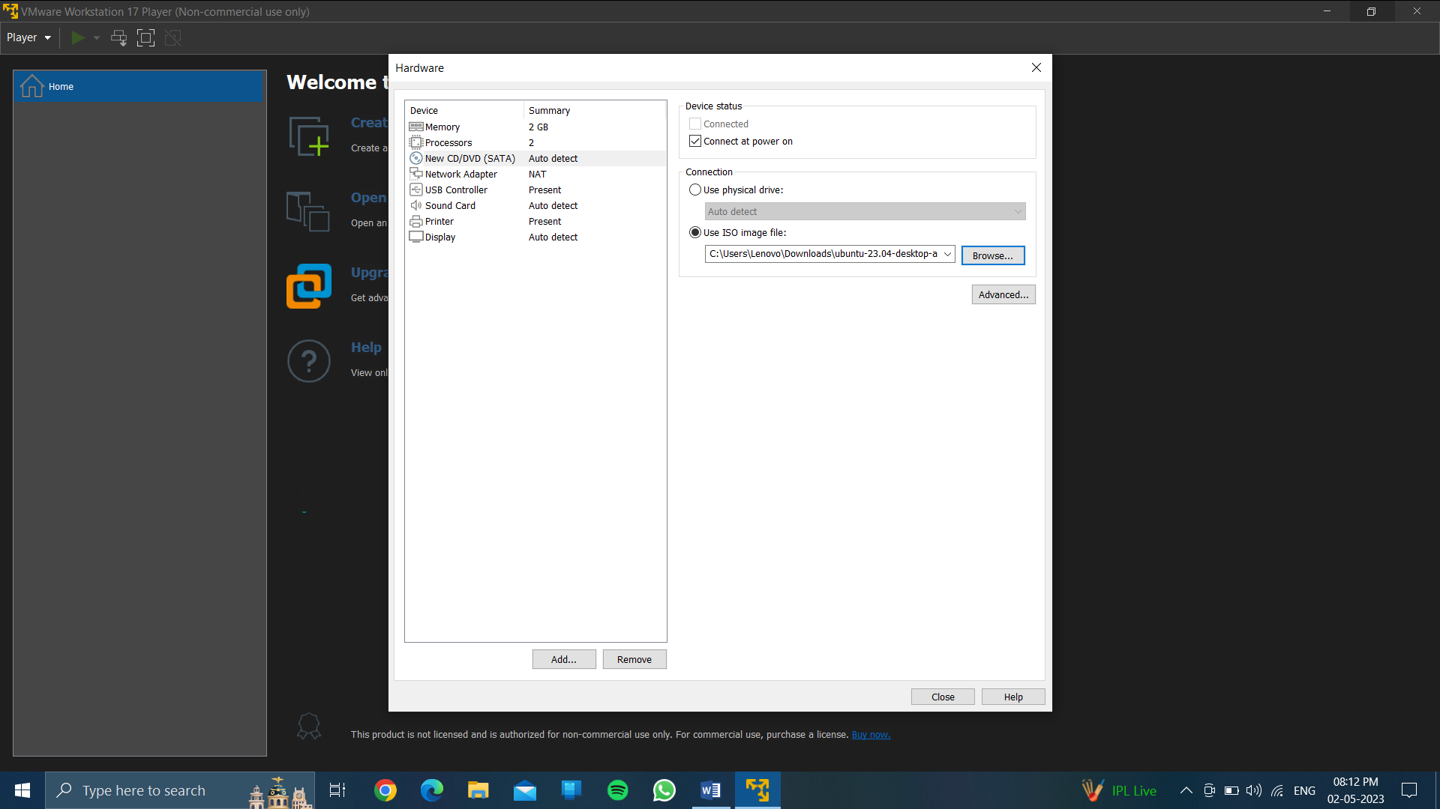

After browsing the file …….

Choose close……

After closing then finish it…..

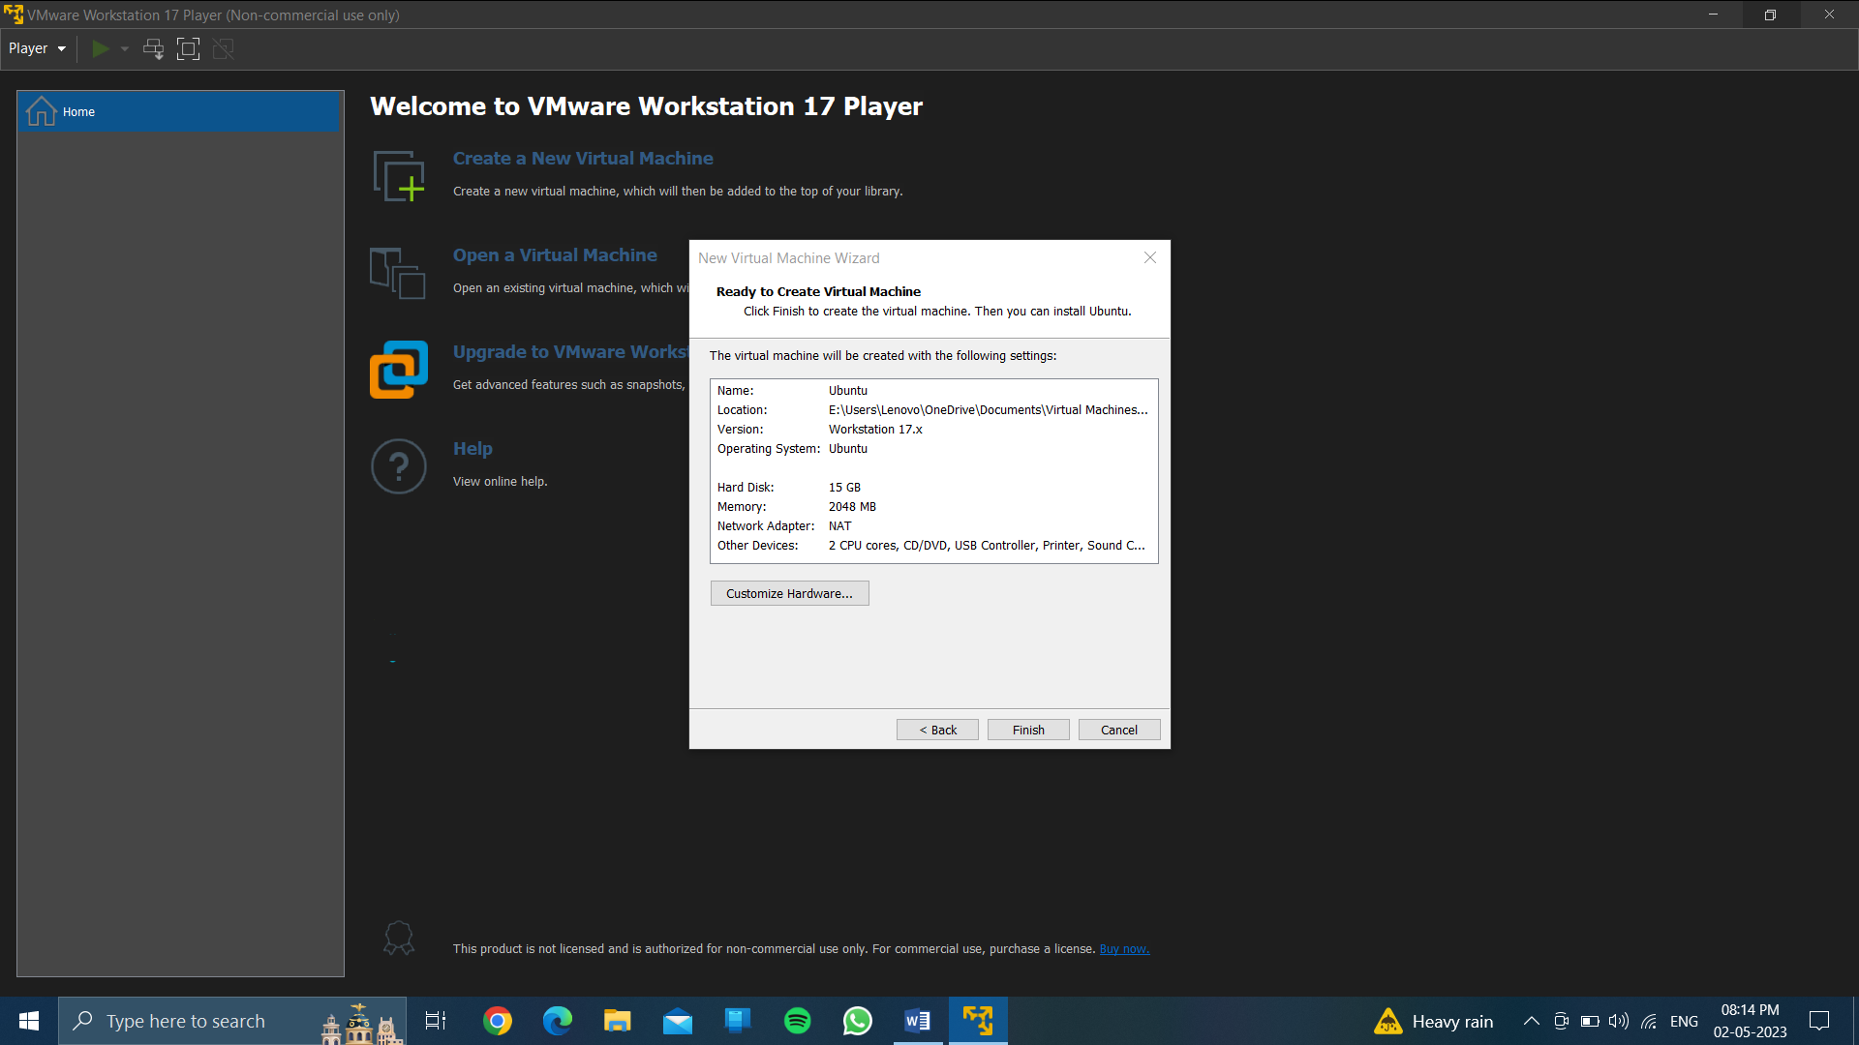

Play virtual machine/power on virtual machine…

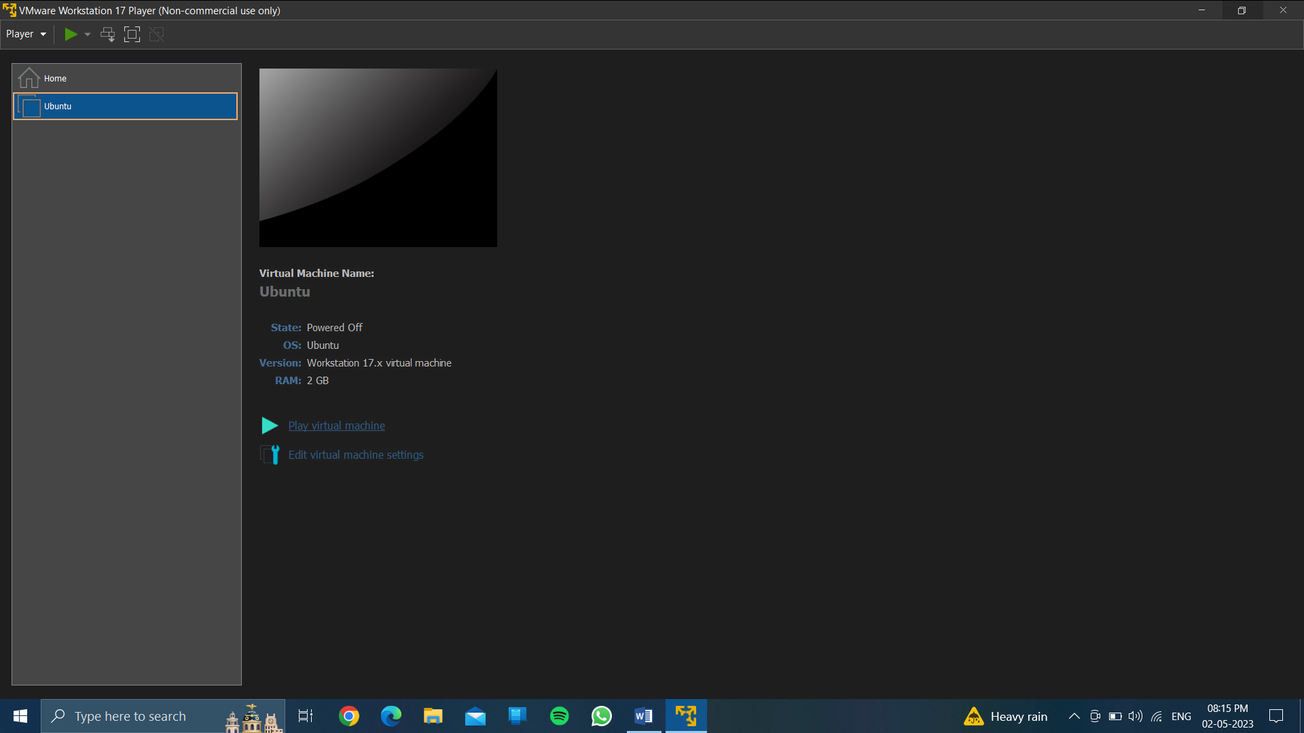

After then you will get output…

Output:

To run the different (os) in one computer through virtual machine….

